The UDP H2S BandMap

1. General

Logger32 has a function to receive and display decoded callsigns with some additional informations on UDP H2S BandMap. This These data is are distributed via UDP (User Datagram Protocol) approximately every at about 15 seconds (FT8 Mode) or 60 seconds (JT65, JT9 Mode etc) by WSJT-X/JTDX program.

When QSO is logged in WSJT-X/JTDX then Logger32 will log this QSO via UDP.

Note 1: When QSO is logged in JTDX then Logger32 wll log this QSO via TCP as well
Note 2: UDP H2S BandMap and JTAlert program DO NOT do not work at same time.
Note 3: If using JTDX, use either TCP Server method OR this UDP server method – NOT both.

2. WSJT-X/JTDX settings
2.1 Settings in WSJT-X program

Look for UDP Server group. You should leave the default value like this.

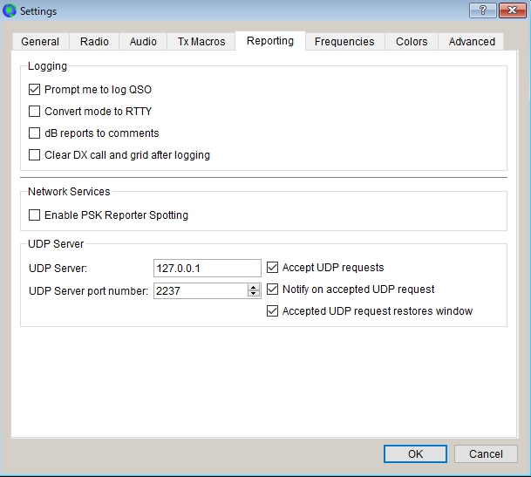

UBM HBM_1

2.2 Settings in JTDX program

Look for UDP Server group. You should leave the default value like this.
If you do not use External logbook connection then uncheck "Enable data transfer to external log"
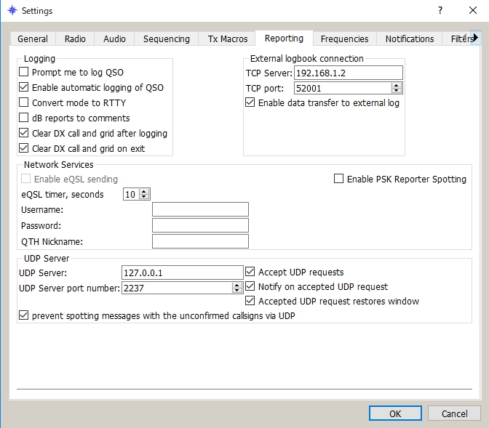

UBM HBM_2

3. Logger32 settings
The callsign highlight colors and DXCC award tracking informations displayed in UDP H2S BandMap depend on the settings in "DX Spot highlight color" and "Setup phone/digital modes"

Settings for me to operate FT8, JT9 and JT65 below.

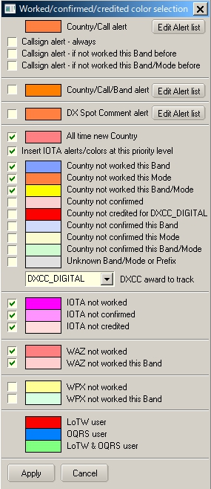

UBM HBM_3

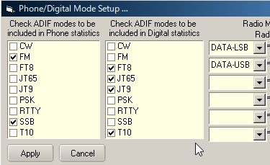

UBM HBM_4
With this settings Worked/confirmed Window looks like below.

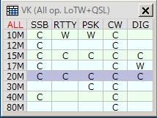

UBM HBM_4A

4. Operation (1)
(a) Run WSJT-X or JTDX. Do not run JTAlert at same time.
(b) Run Logger32
(c) Right click on "UDP H2S" in the lower status bar. Click "Open UDP H2S BandMap"

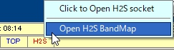

UBM HBM_5

When WSJT-X or JTDX decode callsigns these callsigns are displayed in the UDP H2S BandMap.
WSJT-X or JTDX, Band and Mode are displayed in title bar. Band and Mode are derived from WSJT-X or JTDX.
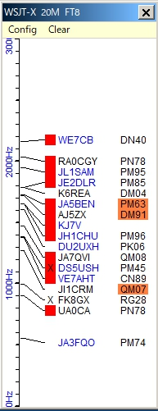

UBM HBM_6

(d) Click "X" to close UDP H2S BandMap.

5. Menu
5.1 Config
There are a lots of options. You may choose whatever you prefer now.
If you want to see highlight colors and tooltips informations based on every mode then un-check "Highlight callsigns as "DIG" mode" This option works for displaying "QSOd B4" mark as well.
If you want to use direct logging then check "Allow QSO automatic logging" If you want to see Gridsquare then check "Show Gridsquares"

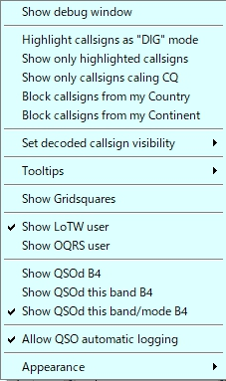

UBM HBM_7

Sub menu for "Set decoded callsign visibility"

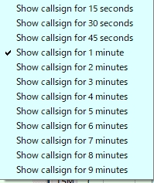

UBM HBM_8

Sub menu for "Tooltips"

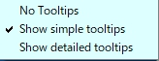

UBM HBM_9

Sub menu for "Appearance"

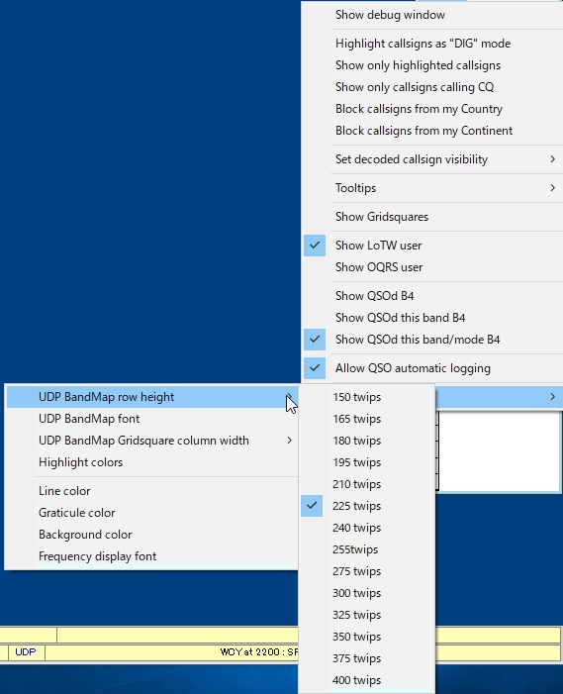

new UBM HBM_10
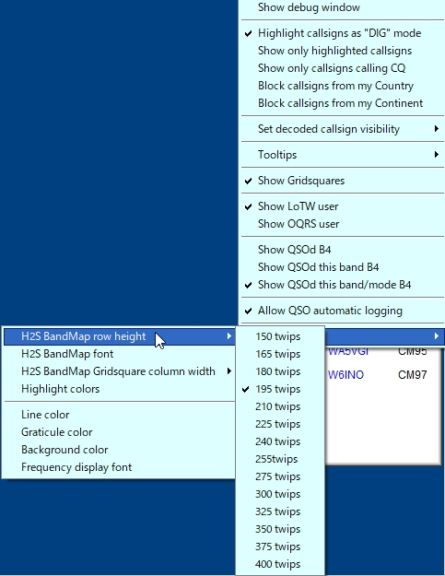
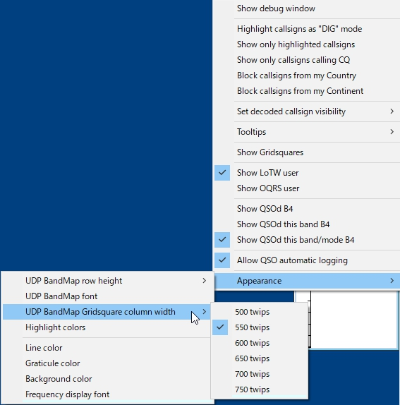

new UBM HBM_10A

Click "Highlight colors" to configure Gridsquare highlight colors and UDP H2S BandMap text color. If you prefer to see bold text for CQing callsign then check "Show bold text when station CQing".

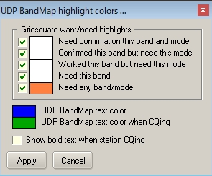

new UBM HBM_11

5.2. Clear
This clears UDP H2S BandMap.

6. Operation (2)
(a) If you move mouse over callsihn then tooltips appears.

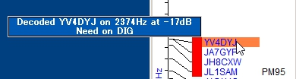

UBM HBM_12

(b) If you left-click any callsign then this callsign is transferred in Logbook Entry Window.

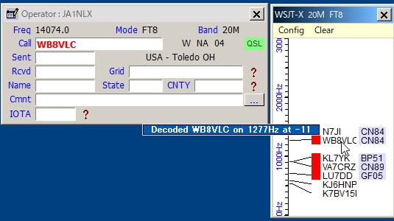

UBM HBM_13

(c) If you right-click any callsign then history of this callsign is displayed. (max 15 messages)

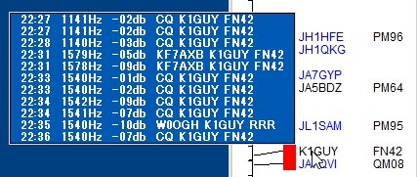

UBM HBM_14

(d) If you confugure various options properly then you see LoTW/OQRS user, QSO B4, highlighted callsign and Gridsquare.

(e) When QSO is logged in WSJT-X/JTDX then Logger32 log this QSO via UDP if "Allow QSO automatic logging" is checked.

7. Tips
(a) If you have "Show only callsigns calling CQ" and "Show only highlighted callsigns" checked then the only station that are highlighted and calling CQ will show.
(b) The BLOCK COUNTRY and BLOCK CONTINENT options look for a Country/Continent match with the Logger32 Current Operator. If you have the Logger32 operator set to "At the Beach" or "Club Station" or something other than the callsign of where you are operation, the results will be unpredictable.

(c) Try to change settings of "DX Spot highlight colors" in DX Spot Window and settings of "Setup phone/digital modes" in Tools menu. It affects the way to display highlight colors and tooltips in UDP H2S BandMap.

(d) Debug window is very useful to check problem. Click "Show debug window" in Config menu to show debug window.

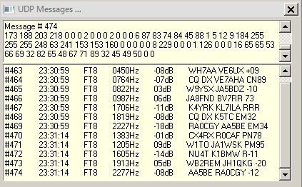

UBM HBM_15

